**Project Report**

**Front end**

Our website features a search bar as the primary method of navigation for our e-Commerce website. Users are able to search for a specific DVD and are provided with a page of results, which they are able to sort by a variety of criteria. The website also provides a secondary method of navigation, which is a dropdown menu located at the top left of the header on every page. From the dropdown menu, the user is able to select a category of film.

We have embedded YouTube trailers within each product page which users can view before they purchase the movie. We have chosen to embed the trailers, as this will keep the user on the site, therefore making it more likely that they will purchase the movie from our store.

We have implemented login and register modals into our website. When a user registers, we store personal information in the database. We collect:

* Email Address and Password (hashed in order to safeguard the data in the event our database is compromised) – used for user authentication
* Date of Birth – Used to verify the user is of age to purchase the movies requested
* Delivery Address – Used so that the user doesn’t have to enter it at every purchase

All data is validated, ensuring it has been entered correctly into each field. We have used modals to facilitate these forms to enable the user to complete these actions without leaving the page that they are currently browsing.

We provide our users with the ability to update their details. We also provide the ability for them to view their past orders and track their current status. We have also implemented a dedicated CMS admin portal. This allows staff to add new products and modify existing products. The CMS also allow staff to view/delete and update the status of customer orders.

We have provided a dropdown shopping cart. This allows users to view/modify their shopping cart from any page. The shopping cart provides the user with a list of products which they have added along with price and the quantity. We use AJAX to keep a server side copy of the users’ shopping cart, therefore meaning that quantities are always live and up to date on the server.

Once a user has completed their browsing, they can press the ‘Checkout’ button at the bottom of their cart. At this stage we make sure the user is logged in, otherwise we display the login/register modals. Finally, we present the user with a summary of their order and provide a button to complete the order.

**Backend of website**

Our website is powered by MongoDB, a document-oriented, NoSQL database. We use this database to store all user, product and order data. We interact with the database using PHP, allowing us to serve dynamic webpages to our users.

We use AJAX on our website in order to transfer data between client and server ‘asynchronously’, therefore allowing data to be updated/modified without refreshing the page.

**Database Design**

Database Name: movie_box

Collections:

* baskets – Contains server-side details of client shopping baskets
* customers – Contains customer details (and sign in data)
* orders – Contains details of customer orders
* products – Contains product/inventory details
* staff – Contains staff login data
* counters – Contains the counters for auto incrementing values

**Sample ‘baskets’ Document:**

{

"_id" : ObjectId("587ffcf28796e9e5814d7dde"),

"last_modified" : ISODate("2017-01-18T23:34:12.000Z"),

"status" : "active",

"items" : [

{

"product_id" : ObjectId("587fe0a48796e9e5814d7914"),

"quantity" : 1,

"product_details" : {

"title" : "Inside Out",

"unit_Price" : 1499,

"artwork" : "http://media.store.hmv.com/app_/responsive/HMVStore/media/product/73042/01-73042.jpg?w=950"

}

}

]

}

**Sample ‘customers’ Document:**

{

"_id" : ObjectId("587ff9568796e9e5814d7d23"),

"email_address" : "john@johnsmith.com",

"password_hash" : "$2y$10$d/aRDu9.Mwmk3bCa3L65AOtcZWJH7mAu13gQcN5qM/3oTdwF0h1qW",

"dob" : ISODate("1975-01-20T20:39:19.197Z"),

"name" : {

"first_name" : "John",

"last_name" : "Smith"

},

"shipping_address" : {

"address_line1" : "Middlesex University",

"address_line2" : "The Burroughs",

"city" : "London",

"postcode" : "NW4 4BT",

},

"tracking" : {

"viewed_product_ids" : [],

"recent_searches” : []

},

"order_ids" : [

ObjectId("587fe197950fce26c2b1100a")

]

}

**Sample ‘orders’ Document:**

{

"_id" : ObjectId("587fe197950fce26c2b1100a"),

"order_number" : 1001,

"status" : "Delivered",

"created" : ISODate("2017-01-18T21:50:00.000Z"),

"updated" : ISODate("2017-01-18T21:50:00.000Z"),

"customer" : {

"id" : ObjectId("587ff9568796e9e5814d7d23"),

"name" : "John Smith",

"address" : {

"address_line1" : "Middlesex University",

"address_line2" : "The Burroughs”,

"city" : "London",

"postcode" : "NW4 4BT",

"country" : "United Kingdom"

}

},

"line_items" : [

{

"product_barcode" : "8717418468446",

"product_title" : "Inside Out",

"quantity" : 2,

"unit_price" : 1499,

"line_price" : 2998

}

],

"total_order_value" : 2998

}

**Sample ‘products’ Document:**

{

"_id" : ObjectId("587fe0a48796e9e5814d7914"),

"barcode" : "8717418468446",

"quantity_available" : 12,

"in_basket" : [

{

"quantity" : 1,

"basket_id" : ObjectId("587ffcf28796e9e5814d7dde"),

"timestamp" : ISODate("2017-01-18T23:34:12.000Z")

}

],

"artwork" : "http://media.store.hmv.com/app_/responsive/HMVStore/media/product/73042/01-73042.jpg?w=950",

"price" : 1499,

"details" : {

"title" : "Inside Out",

"description" : "Award-winning animated comedy drama from Disney/Pixar featuring the voice talents of Amy Poehler, Phyllis Smith, Bill Hader, Lewis Black and Mindy Kaling. When eleven-year-old Riley (Kaitlyn Dias) is forced to relocate to San Francisco after her dad gets a new job she has trouble adjusting to her new surroundings. Her emotions - Joy (Poehler), Sadness (Smith), Fear (Hader), Anger (Black) and Disgust (Kaling) - that reside in Headquarters, the control centre of her mind, try to help her navigate her way through the big change. However, after a slight mishap at Headquarters the situation gets out of hand, causing Riley's emotional state to worsen. Will the five emotions be able to restore order and make Riley feel better about her new life? The voice cast also includes Richard Kind, Diane Lane, Kyle MacLachlan and Frank Oz. The film won the Golden Globe Award for Best Animated Feature Film and the BAFTA and Academy Award for Best Animated Film.",

"release_date" : ISODate("2015-11-23T00:00:00.000Z"),

"format" : "DVD",

"certificate" : "U",

"duration" : 91,

"audio_language" : [

"English",

"Italian"

],

"studio" : [

"Walt Disney"

],

"director" : [

"Pete Docter"

],

"cast" : [

"Amy Poehler",

"Bill Hader",

"Lewis Black"

],

"category" : [

"Animation",

"Adventure",

"Comedy"

],

"trailer_url" : " https://youtu.be/WIDYqBMFzfg"

}

}

**Sample ‘staff’ Document:**

{

"_id" : ObjectId("5880000c8796e9e5814d7e8c"),

"name" : {

"first_name" : "Jane",

"last_name" : "Doe"

},

"email_address" : "jane@janedoe.com",

"password_hash" : "$2y$10$oFntKTr/n6LMrKHK8rZRAOQgLHvq3rYAu9GTXMgOsZrN91BFcxo2K"

}

**Sample ‘counters’ Document:**

{

"_id" : "order_number",

"value" : 1001

}

**Third Party Libraries Used:**

* Bootstrap
* JQuery
* VenoBox

Screenshots of all pages:

Home page with the checkout/basket:

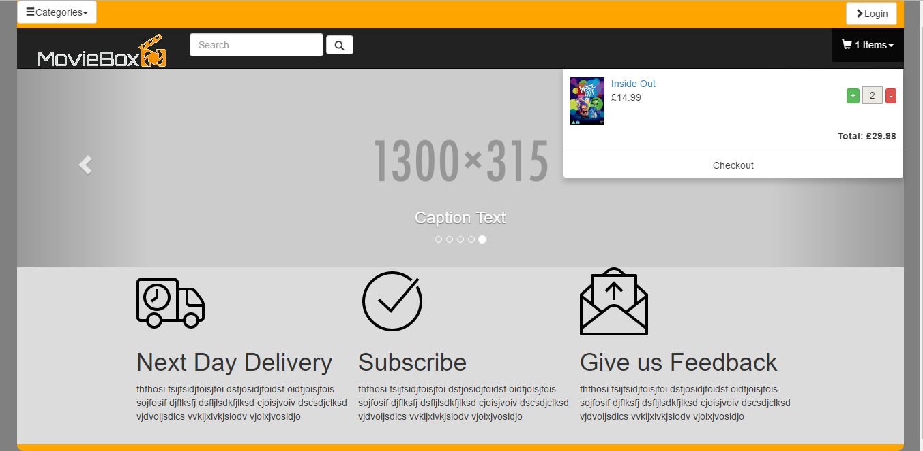

Home page with the categories dropdown:

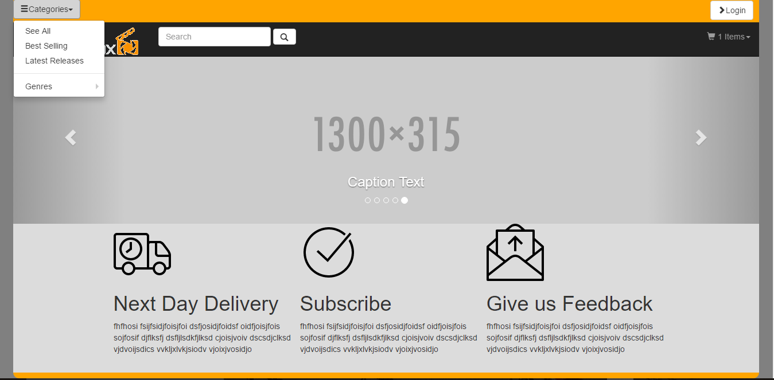

Login page:

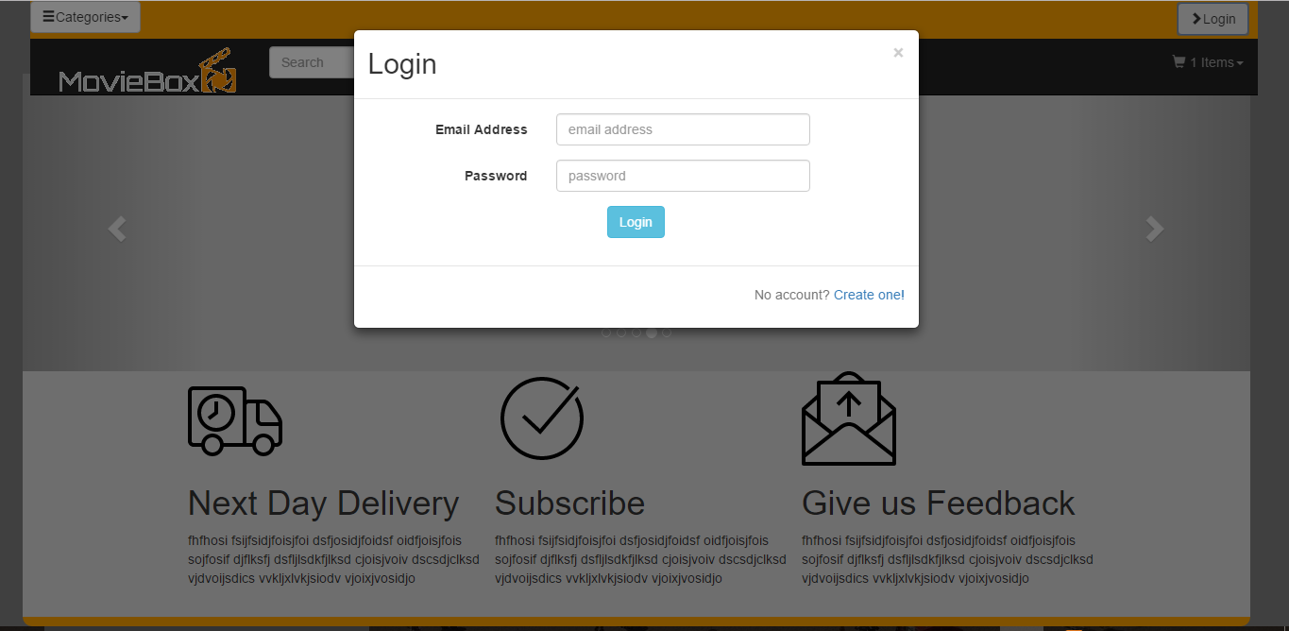

Register page:

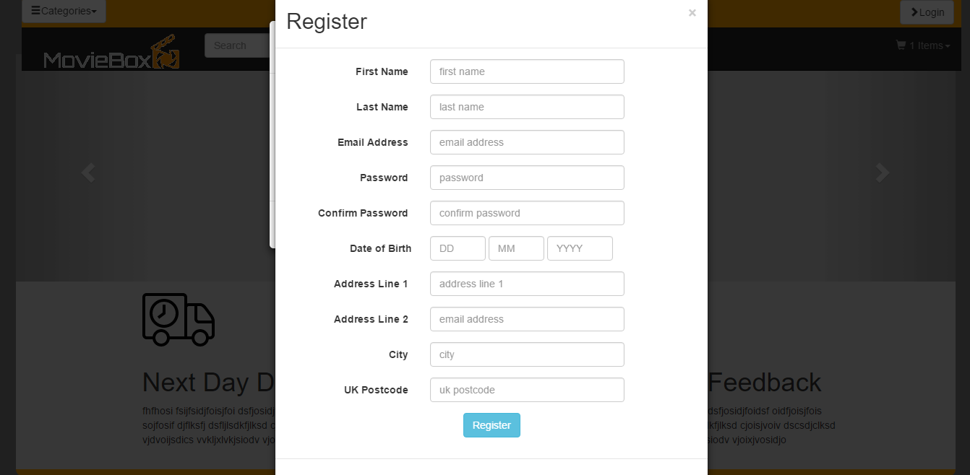

Search results page:

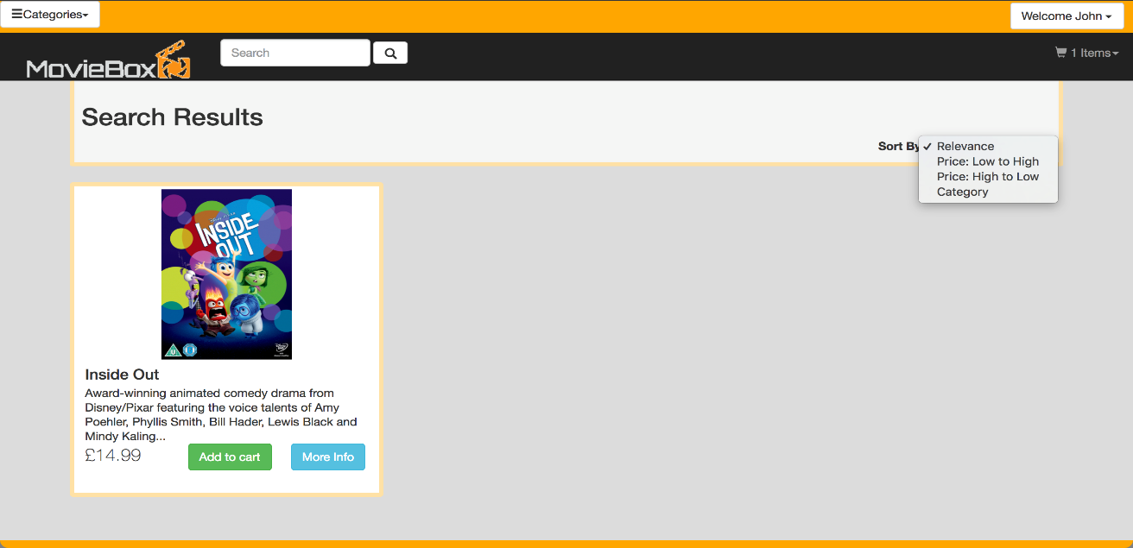

Once logged in drop down to edit details orders, my orders and logout can be viewed with sort by option:

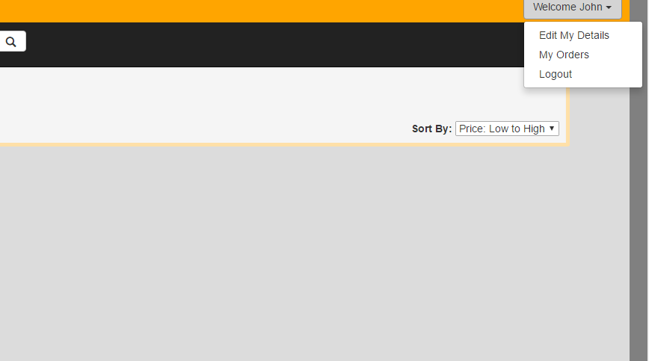

Description of the product:

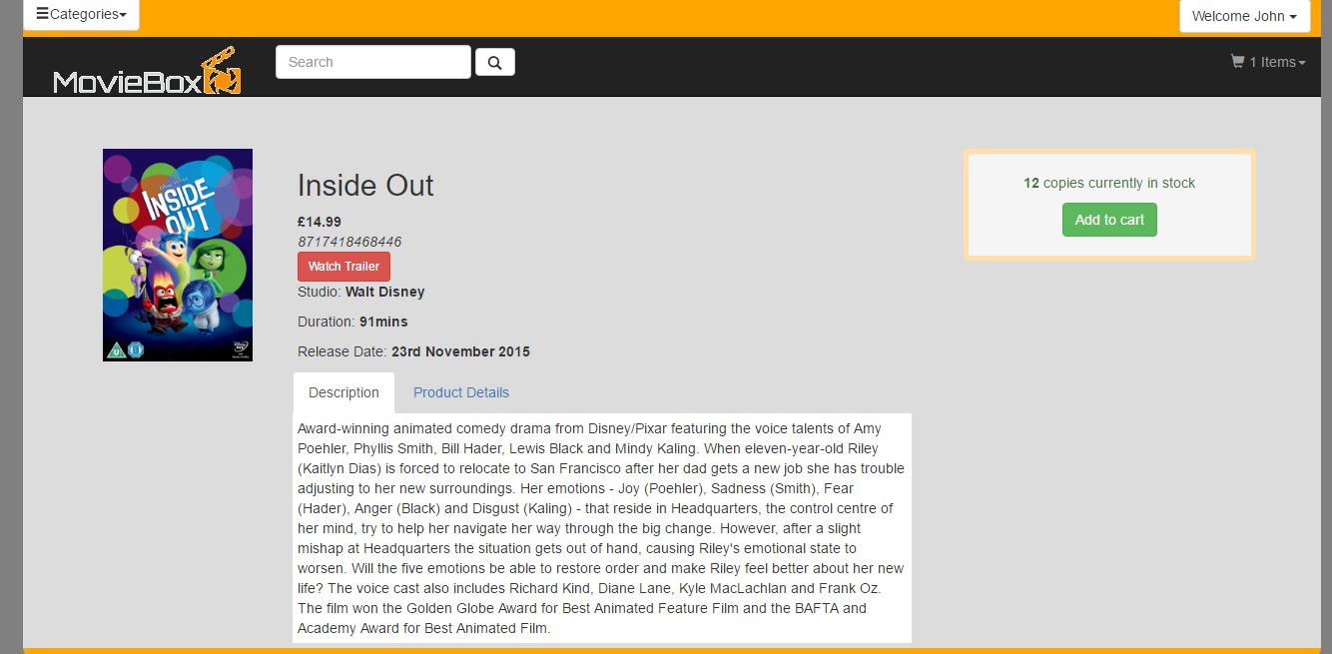

Product details:

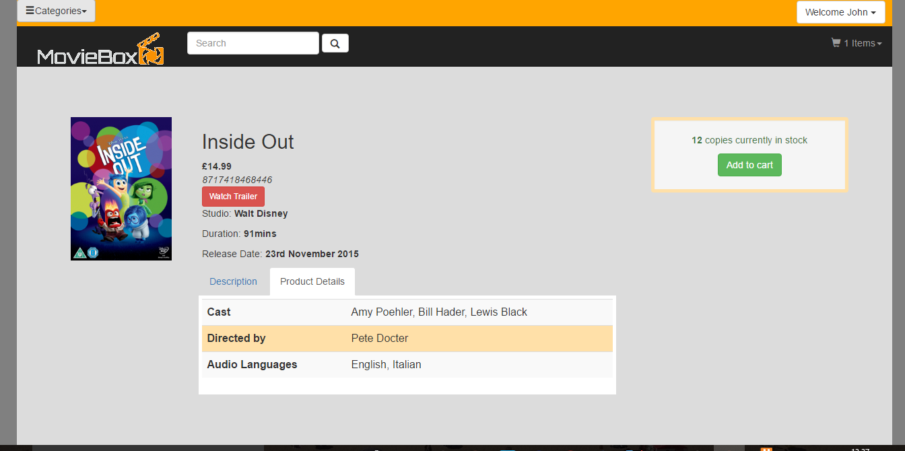

Trailer of the product selected:

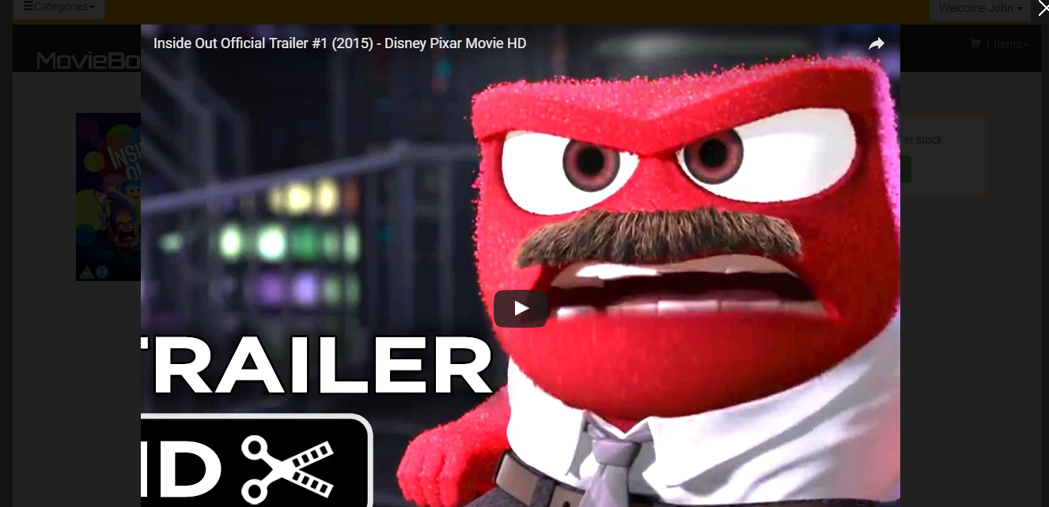

Check out page with recommendations:

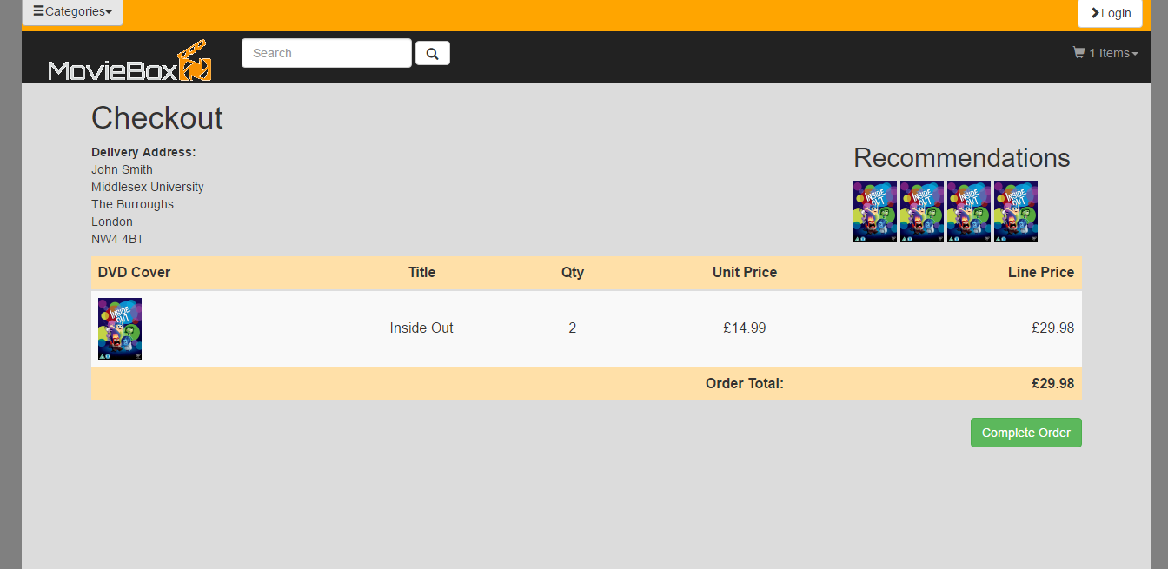

Confirmation page once order is completed:

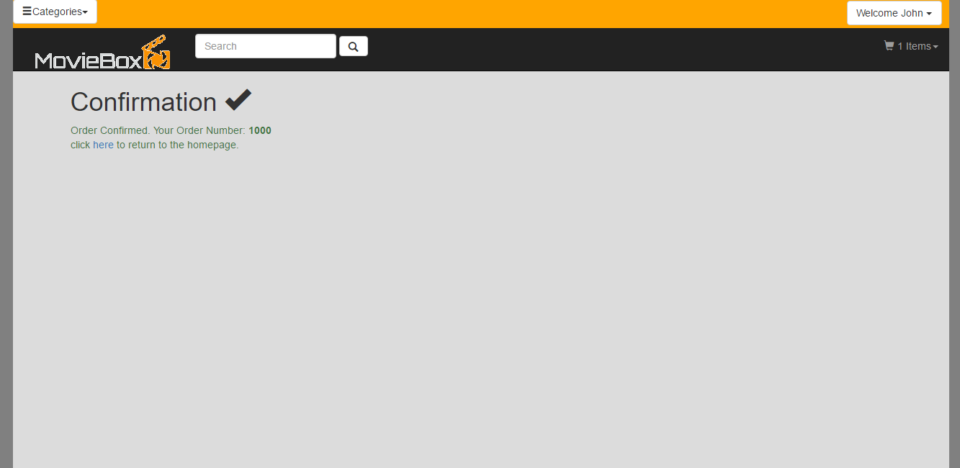

Option to edit personal details once signed in:

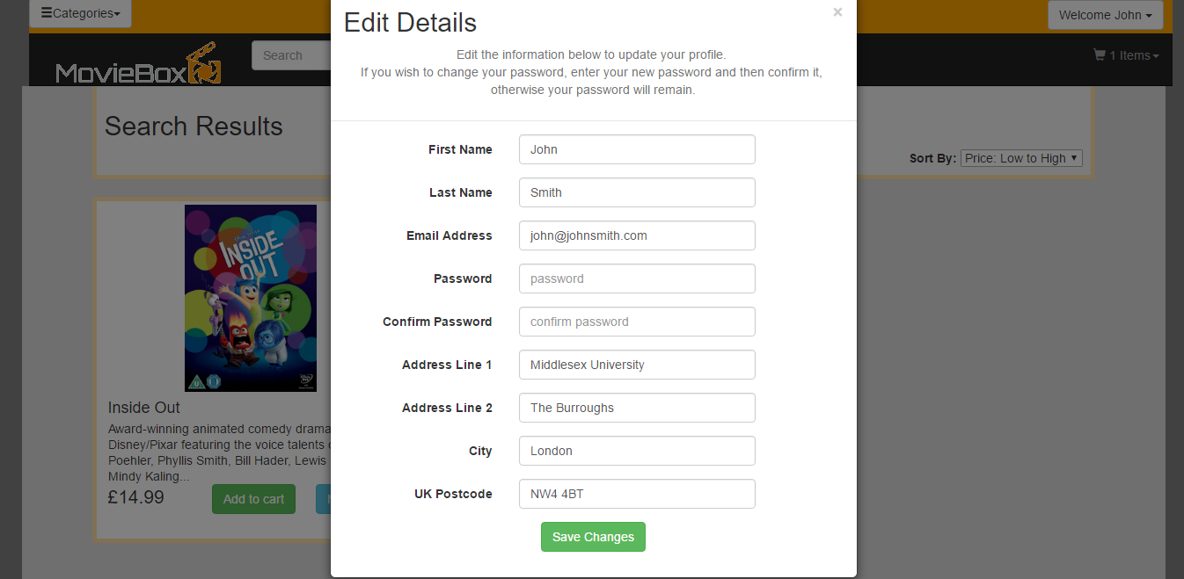

Orders are viewed:

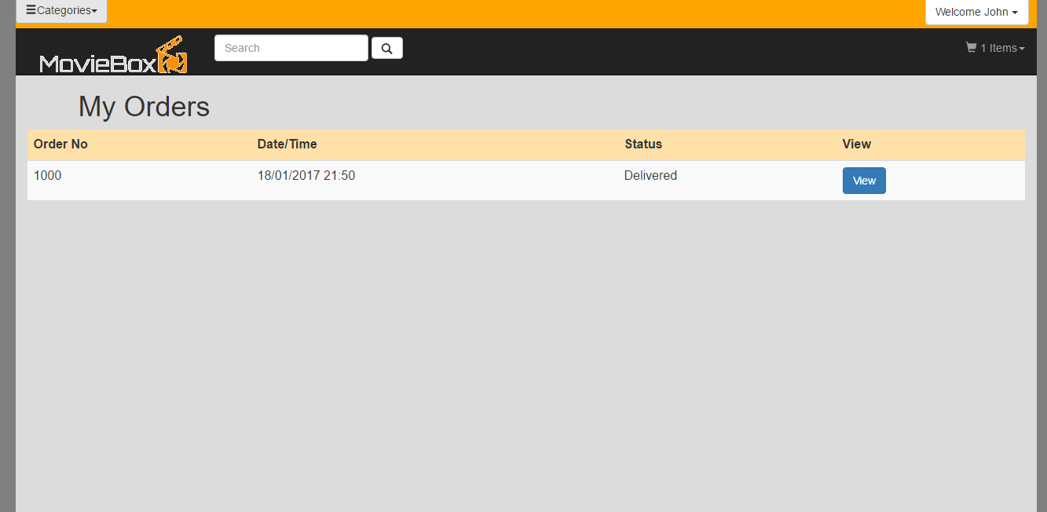

Orders details:

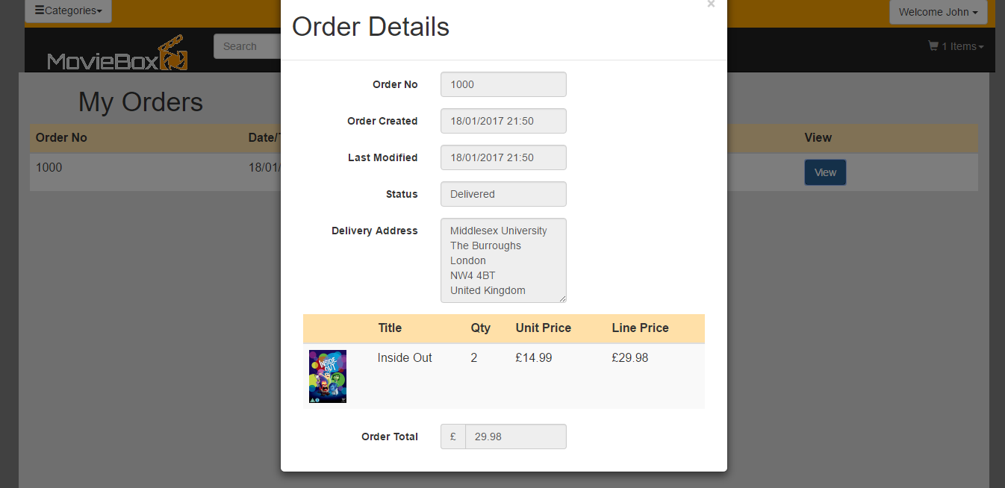

CMS login:



Orders are viewed:

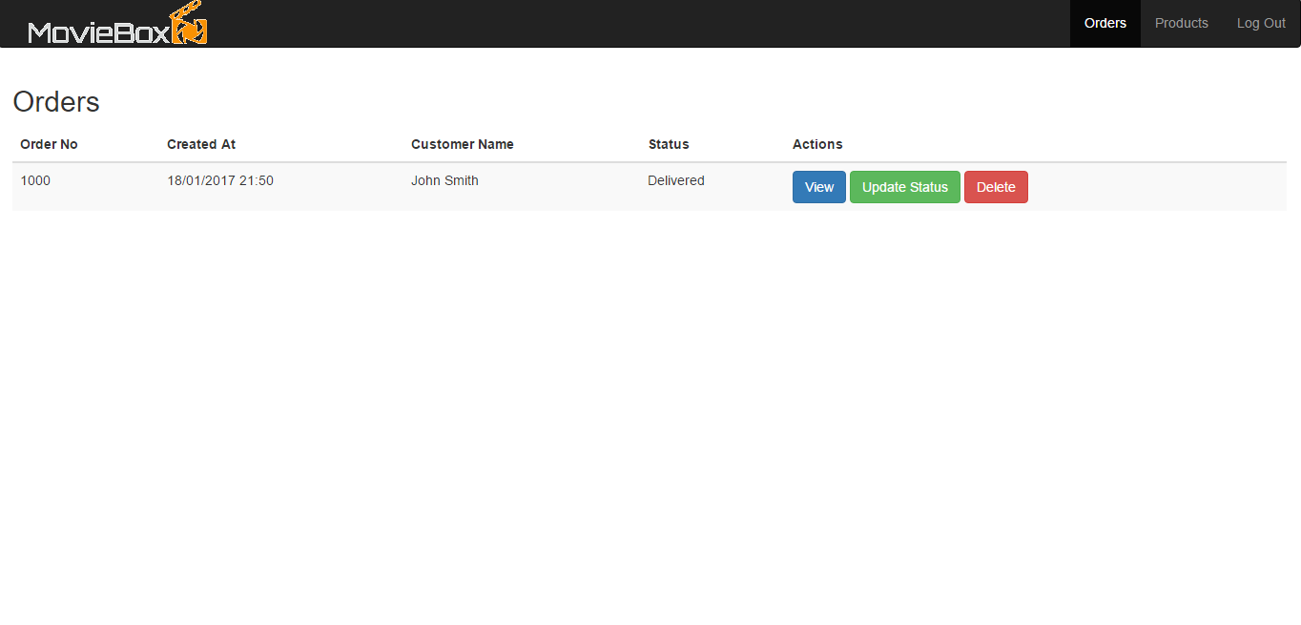

Order details:

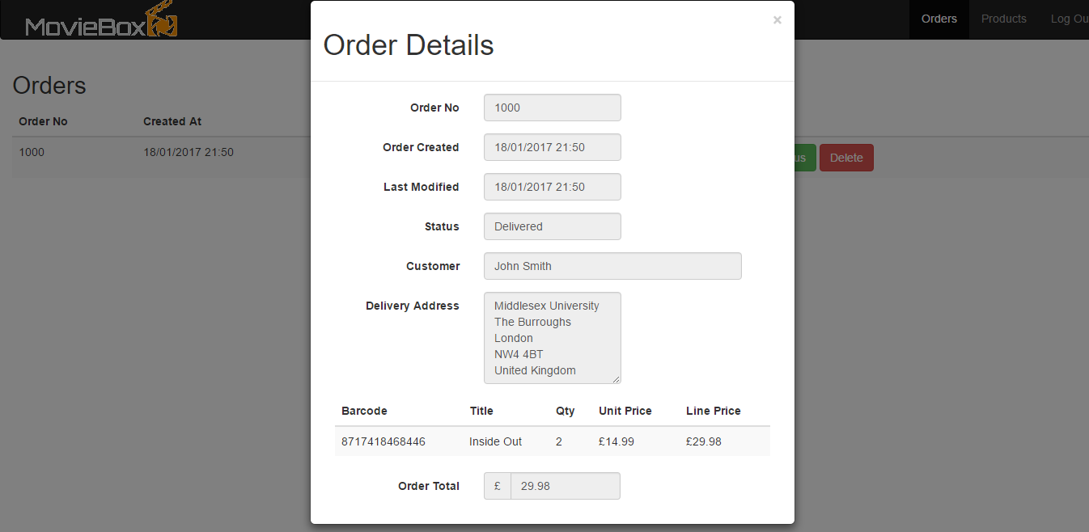

Order status:

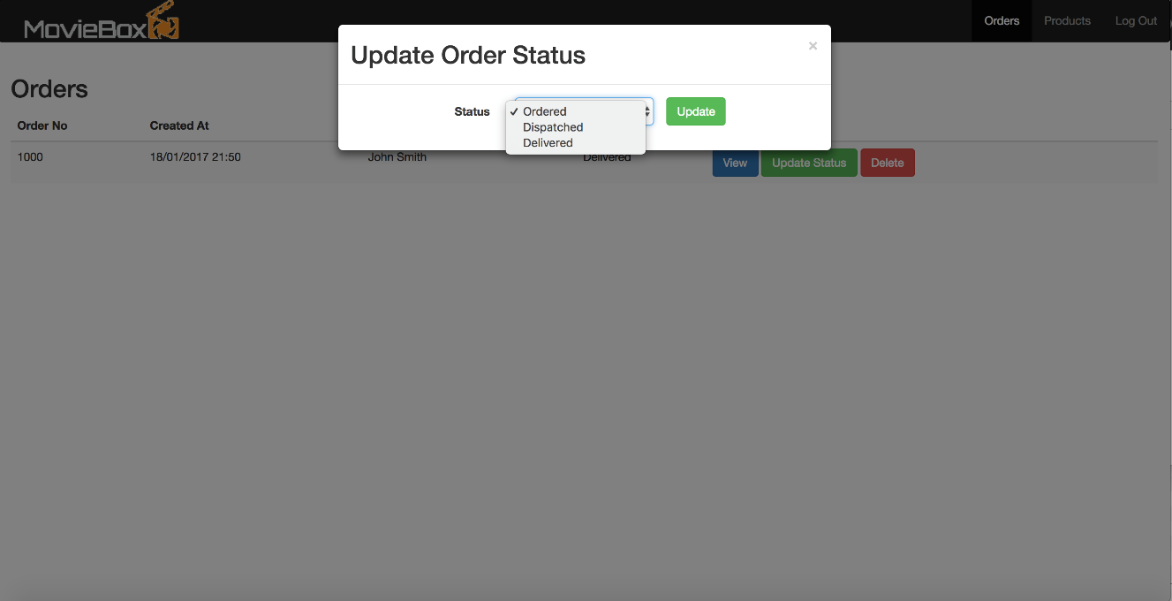

Edit orders:

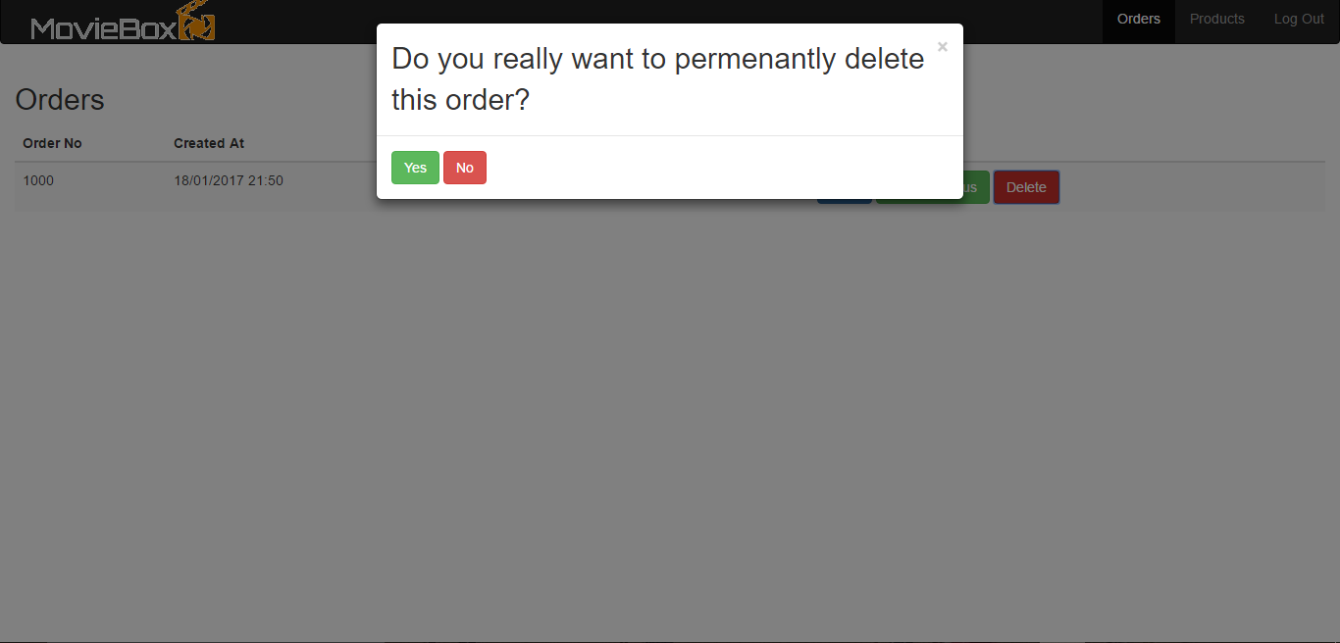

Products:

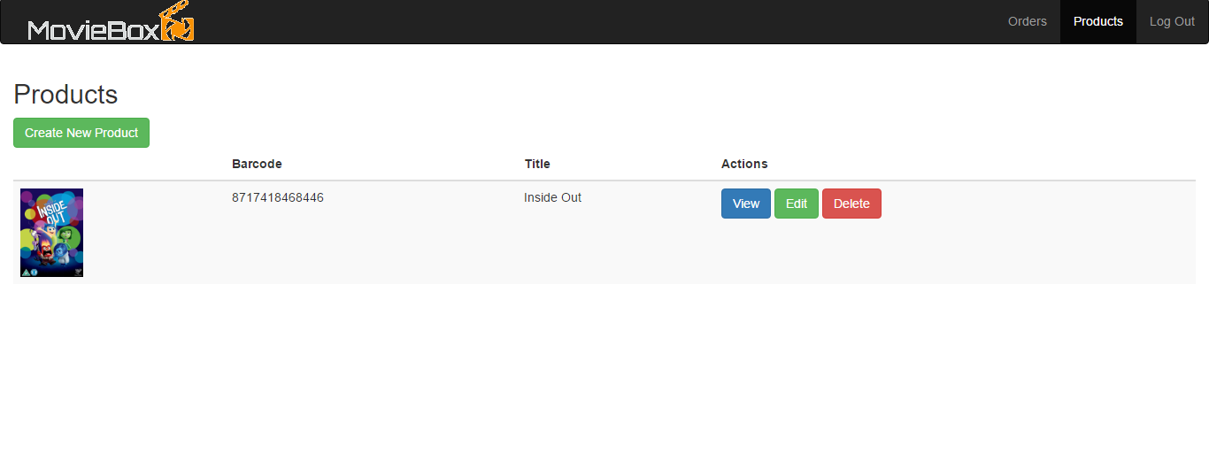

Create new product:

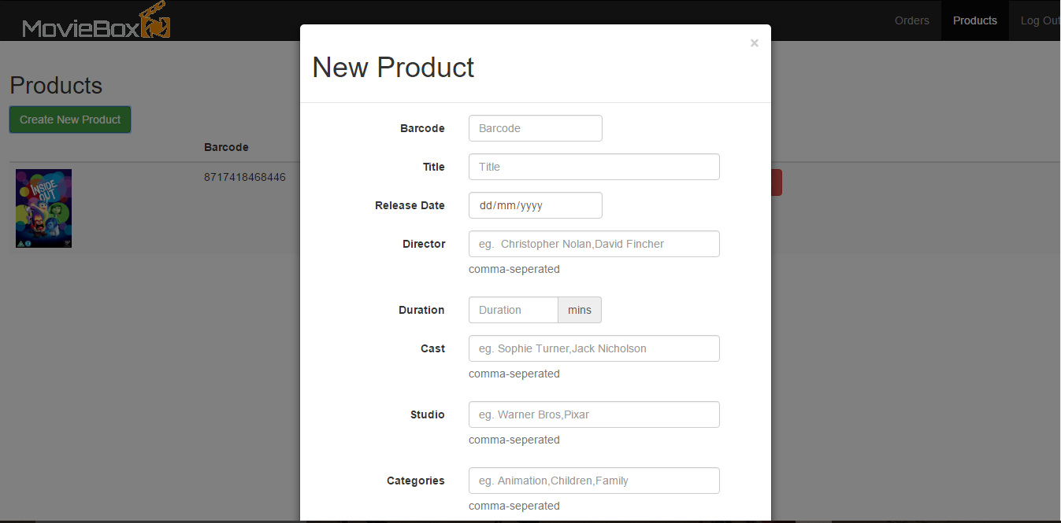

View product information:

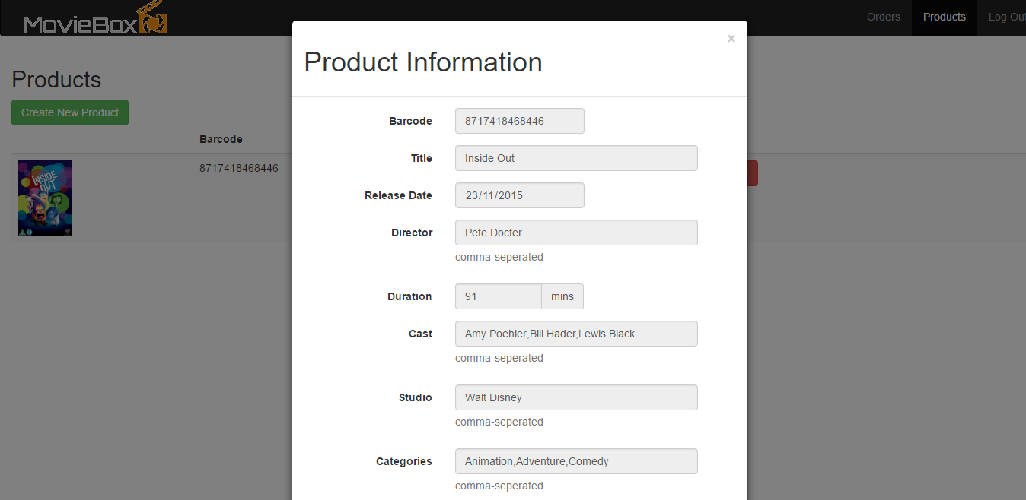

Edit product details:



**Where we are:**

We have completed a prototype of our website. This is a completely static website but includes all features. The website still isn’t completed yet, we still need to add PHP to make it dynamic and add CSS.

**Contribution Table:**

|  |  |  |
| --- | --- | --- |
| Name | Contributions to Project | Total Amount of Work on a Scale from 0 to 10 |
| **Timothy Cole** | * Database Design * CMS * Shopping Basket * Login/Register * Checkout * User Details * User Order Management | **10** |
| **Yusuf Mohammed** | * Project Report * Screenshots * Confirmation Page | **6** |
| **Monika Wiercinkska** | * Wireframes * Main Page * Main Stylesheet * Search Results * Product Page | **8** |